

**Smoke Free Workplaces Project  
Request for Applications**

**Responses due Tuesday, January 31, 2023**

Reducing smoking and vaping among staff and promoting a smoke free workplace helps protect the entire workforce from the harms of tobacco smoke and improves health, morale and team performance. A workplace can create a smoke free environment with clear policies, signage and resources to help employees quit. The Kane County Tobacco Control and Prevention program aims to collaborate with area businesses and nonprofit organizations to promote quitting tobacco use among adults and youth, eliminate secondhand smoke exposure, and promote compliance with Smoke Free Illinois Act​.

**The Kane County Health Department (KCHD) is offering Kane County businesses and organizations $750 in support of workplace anti-smoking and vaping policy development, clear signage for staff and visitors, and smoking and vaping cessation resources for employees.**

**Eligibility**Your workplace can apply if:

* It is a business or nonprofit organization based in Kane County, Illinois
* Registered with the State of Illinois and have an Employer Identification Number (EIN)
* Your workplace has the authority to change policies that affect employees and visitors.

**Project Objectives**This project is designed to assist your workplace in taking steps toward creating a healthier, smoke free  
workplace. Funding recipients must complete the following three objectives by June 30, 2023:

1. SMOKE FREE POLICY

* Develop an organizational policy that prohibits both smoking and vaping   
  OR
* Update an existing policy that already prohibits smoking to include vaping.
* The Smoke Free Illinois Act requires that workplaces are completely smoke-free inside and within 15 feet from entrances, exits, windows that open and ventilation intakes. Consider a policy that makes your entire property smoke free, including all outdoor spaces beyond 15 feet.
* See page 6 of this document for a sample policy.

2. SIGNAGE AND ASH TRAYS

* Clearly and conspicuously post No Smoking and No Vaping signage at visitor and employee entrance points.
* Remove all ash trays in areas where smoking is prohibited.
* See page 6 of this document for signage examples.

3. QUITTING RESOURCES

* The business or organization will become an Illinois Tobacco Quitline (ILTQ) Referral Partner by completing a brief form ([electronically fillable form is available here](https://www.kanehealth.com/Documents/Tobacco/ITQL%20Fillable%20Referral%20Partners%20Enrollment%20Form.pdf)) and returning it with this completed application to: [kanequits@kanecountyil.gov](mailto:kanequits@kanecountyil.gov)
* Becoming an ILTQ Referral Partner allows you to provide employees who wish to quit smoking or vaping with information about the ILTQ, where they can receive free one-on-one cessation counseling and free nicotine replacement products. Free smoking and vaping cessation handouts and posters are also available to ILTQ Referral Partners.

**Application Assessment Criteria**  
All eligible applications will be assessed against the following criteria and weighted as indicated below:

1. Commitment (20%): Staff members have been identified and are supported to lead in the completion of the three objectives (policy, signage and quitting resources).

2. Assessment (30%): The smoking and vaping situation at your business or organization is detailed, and potential challenges to completing the three objectives are identified.

3. Action (50%): Ability to complete the three objectives by June 30, 2023. Businesses and organizations will also be ranked on number of employees affected by the policy change.

**Application Timeline**

|  |  |
| --- | --- |
| Applications open | December 12, 2022 |
| Applications (with completed ILTQ Referral Partner form) due | January 15, 2023 |
| Applicants notified and awardees are sent Project Agreement and New Vendor Form | January 31, 2023 |
| Awardees return Project Agreement, New Vendor Form, and invoice | February 6, 2023 |
| Payout to business/organization by | March 6, 2023 (approximate date) |
| Progress update due | June 15, 2023 |

**Electronic Submission**  
Submit the application, completed electronically, along with [the Illinois Tobacco Quitline Referral Partner Form](https://www.kanehealth.com/Documents/Tobacco/ITQL%20Fillable%20Referral%20Partners%20Enrollment%20Form.pdf) to [kanequits@kanecountyil.gov](mailto:kanequits@kanecountyil.gov) with the subject line, “Smoke Free Workplaces Project Application” by Friday, January 15, 2023.

**Questions?**  
Contact the Kane County Tobacco Control & Prevention Program by email: [kanequits@kanecountyil.gov](mailto:kanequits@kanecountyil.gov)



**Smoke Free Workplaces Project Application**

Please complete electronically and email to [kanequits@kanecountyil.gov](mailto:kanequits@kanecountyil.gov) by January 15, 2023.

Organization Click or tap here to enter text.

Contact name Click or tap here to enter text.

Role within agency Click or tap here to enter text.

Phone Click or tap here to enter text.

Email Click or tap here to enter text.

Postal address Click or tap here to enter text.

EIN Click or tap here to enter text.

Is the individual named above the person to lead the changes within your organization?

Yes

No

1. Explain if/how leadership and employees at other levels or sectors within the workplace will help with this initiative?

Click or tap here to enter text.

2. Explain the smoking and/or vaping situation at your workplace (e.g., is smoking and vaping frequently witnessed? Have there been employee complaints to management?)

Click or tap here to enter text.

3. Do you expect any challenges to putting the three grant objectives (policy, signage, or cessation resources) into action? If yes, please explain below.

Yes

No

Click or tap here to enter text.

4. Do you currently have a smoke free policy for employees and visitors? If yes, please include your current policy below.

Yes

No

Click or tap here to enter text.

5. Do you currently have No Smoking and/or No Vaping signage posted?

Click or tap here to enter text.

6. Do you currently make smoking cessation information available to your employees? If yes, please explain.

Yes

No

Click or tap here to enter text.

7. What is the total number of employees (if your business or organization has multiple locations, list number at Kane County locations only)?

Click or tap here to enter text.

8. Will you be able to develop and make-effective a company-wide smoke and vape policy by June 30, 2023? If no, please explain.

Yes

No

Click or tap here to enter text.

9. Will you be able to clearly and conspicuously post No Smoking and No Vaping signage at visitor and employee entrance points by June 30, 2023? If no, please explain.

Yes

No

Click or tap here to enter text.

10. Once you become an Illinois Tobacco Quitline Referral Partner by completing [this form](https://www.kanehealth.com/Documents/Tobacco/ITQL%20Fillable%20Referral%20Partners%20Enrollment%20Form.pdf), will you provide Quitline information to employees who wish to quit smoking or vaping, and keep track of the number of employees you refer to the Quitline?

Yes

No

Click or tap here to enter text.

**Signatures**

Applicant

Name: Click or tap here to enter text.

Signature: 

Role: Click or tap here to enter text.

Date: Click or tap here to enter text.

Organization Leadership / Management (if different from applicant)

Name: Click or tap here to enter text.

Signature: 

Role: Click or tap here to enter text.

Date: Click or tap here to enter text.



**Sample Smoke/Vape Free Workplace Policy**May be modified to fit the circumstances of your business or organization.

A tobacco-free environment helps create a safe and healthy workplace. Smoking and secondhand smoke are known to cause serious lung diseases, heart disease and cancer. [EMPLOYER] recognizes the hazards caused by tobacco use and exposure to secondhand tobacco smoke. Our policy to provide a tobacco-free environment for all employees and visitors was established to keep a safe and healthy workplace environment. This policy covers the smoking of any tobacco product and the use of oral tobacco products, “spit" tobacco and e-cigarettes, and it applies to both employees and non-employee visitors of [EMPLOYER].

**Policies**

**OPTION 1 – COMPLETE TOBACCO-FREE POLICY**

No use of tobacco products including cigarettes and “spit tobacco” or e-cigarettes is permitted within the facilities or on the property of [EMPLOYER] at any time, including company owned vehicles.

**OPTON 2 – TOBACCO-FREE IN DESIGNATED OUTDOOR AREAS ONLY POLICY**

No use of tobacco products including cigarettes, e-cigarettes and “spit tobacco” will be allowed within the facilities of [EMPLOYER] at any time. Smoking or tobacco use shall be permitted only in designated smoking areas located at least 15 feet outside the building entrance, operable windows, and ventilation systems of enclosed areas to prevent tobacco smoke from entering those areas. All materials used for smoking in designated smoking areas, including cigarette butts and matches, will be extinguished and disposed of in appropriate containers.

**Procedure**

1. Employees will be informed of the [EMPLOYER] Tobacco-free Policy through signs posted throughout properties owned and operated by [EMPLOYER], including company owned vehicles.

2. Visitors will be informed of the [EMPLOYER] Tobacco-free Policy by their hosts, the meeting invite, email correspondences and signs posted throughout the properties owned and operated by [EMPLOYER].

3. [EMPLOYER] will help employees who want to quit smoking by helping them access the Illinois Tobacco Quitline.

4. Any violations of this policy will be handled through the standard disciplinary procedure.

[INSERT SIGNATURE] [INSERT DATE]

SIGNATURE CEO or PRESIDENT DATE



**Examples of No Smoking, No Vaping Signage**

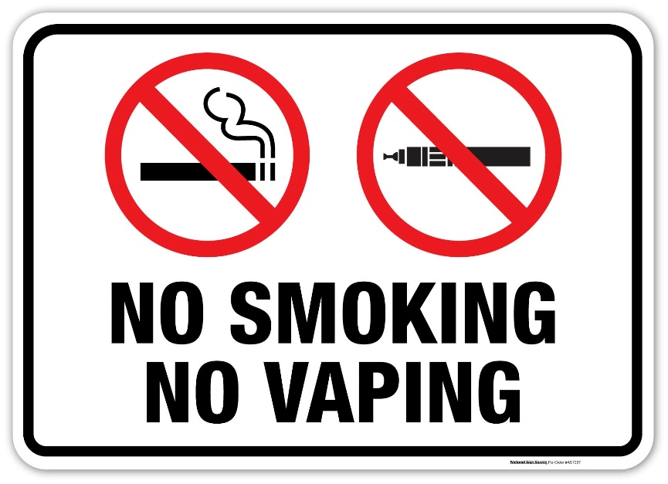

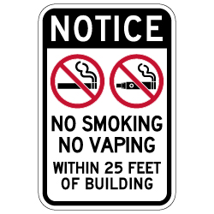

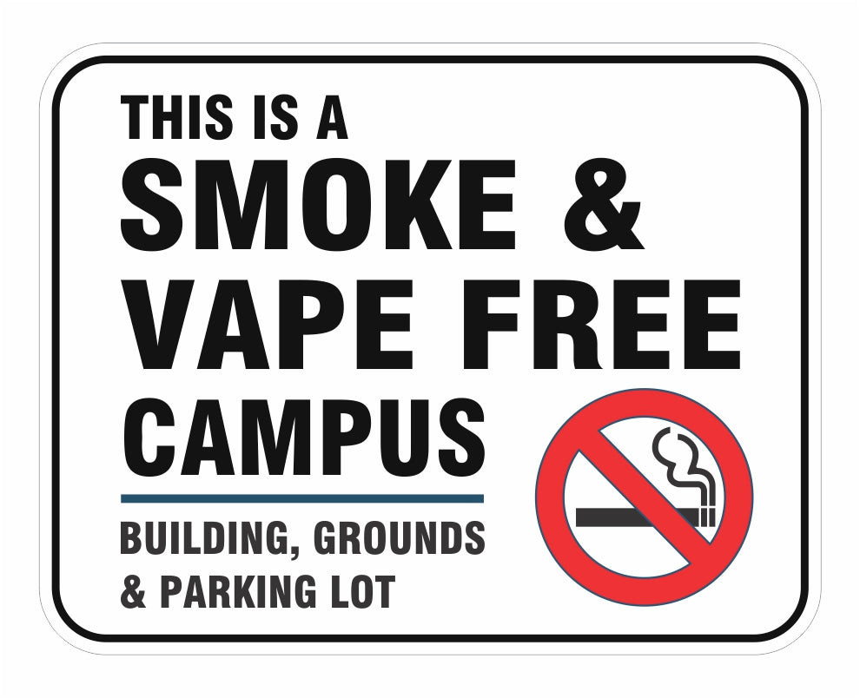

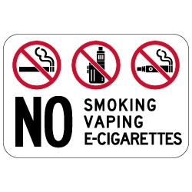

Employers may design their own signs, however, per the Smoke Free Illinois Act, signs must include the international "No Smoking" symbol, consisting of a pictorial representation of a burning cigarette enclosed in a red circle with a red bar across it.